SERVICES AVAILABLE:

We offer a wide range of services:

- Ante-natal  - Cervical Smears  - Child Health Check  - Child and Adult Immunisation  - Diabetes  - Family Planning/ Contraception  - Health Checks  - Hypertension  - Minor Surgery | - Phlebotomy  - Respiratory Clinics  - Long Term conditions  - Sexual Health  - Social Prescribing  - Health Visitors  - Private medicine e.g. DNA testing, medicals.  - Physiotherapist

We offer a range of travel vaccinations. Not all vaccinations are free on the NHS. Please ask at Reception for further details.

Please ensure you allow 6-8 weeks’ notice prior to departure.

VISIT OUR WEBSITE
Please visit our website for further information on the services we offer and other useful information. There are also a number of questionnaires that can be completed online including Friends & Family Test. Our website address is www.thecharnwoodpractice.co.uk

REGISTRATION
Reception staff will guide you through the procedure. Eligibility can be confirmed via proof of address so please provide a recent utility bill as well as one photo ID. You will need to complete a registration form and a health questionnaire.

CONFIDENTIALITY & DATA PROTECTION
We are governed by Data Protection Acts and as such will treat any information held about you confidentially. Any access to your medical records/information by third parties, e.g. insurance companies, will always be subject to your consent.

Access to medical records - Please ask at reception for details. We are registered under the Data Protection Act.

PRACTICE LOCATION
The map below shows the location of the surgery.
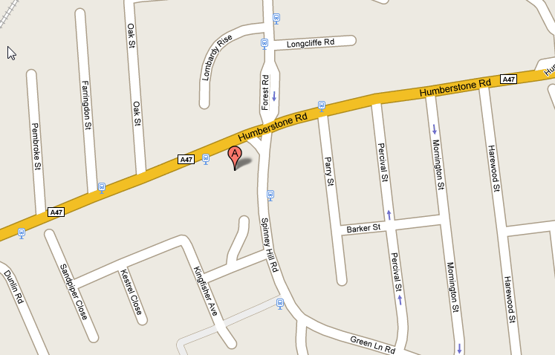
The Charnwood Practice is located in SECTION E.
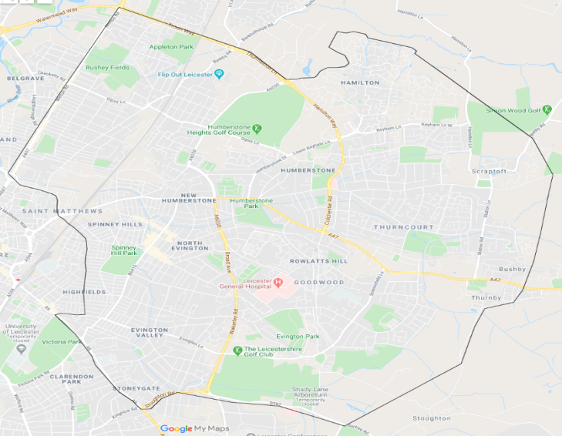
The map below shows the catchment area of the surgery.

PATIENT PARTICIPATION GROUP
We have a patient participation group (PPG) that meet monthly. This is made up of the practice management team and patients.
We work closely together at improving the services provided by the practice. If you are interested in joining the PPG please ask at reception for further details.
NHS LLR INTEGRATED CARE BAORD
The ICB is part of the integrated care system (ICS) with partners in LLR and will deliver a health and care system that tackles inequalities in health and improves the health, wellbeing and life experiences of our local population. These include services provided by doctors’ surgeries, dental practices, opticians, and pharmacies.
NHS Leicester, Leicestershire, and Rutland Integrated Care Board
Room G30, Pen Lloyd Building, County Hall, Glenfield, LE3 8TB 0116 295 7572
                - The Charnwood Practice

                - Merlyn Vaz Health & Social Centre

                - 1 Spinney Hill Road
Leicester
                - LE5 3GH

     0116 294 3100

www.thecharnwoodpractice.co.uk

“Putting our Patients at the heart of everything we do”

MEET THE TEAM
General Practitioners
Dr Alison Mawby  (Female)  Partner  MBBS BSc DFSRH MRCGP  Dr Muzna Parpia (Female)  GP  BMedsci MBchB MRCGP DRCOG | Dr Mahbubur Choudhury (Male)  Partner  MBCHB MRCGP DRCOG

Other Healthcare Professionals
Jagoda Kiesznowska  Nurse Manager  Denise Prendergast  Nurse Manager  Jenna Bray  Health Care Assistant | Jonathan Mawby  Paramedic Practitioner  Ann Walsh  Practice Nurse

Management
Julie Walton  Operations Manager | Paul Houseman  Business Manager
We are supported by our dedicated Patient Services Team.

We also offer clinics with our Primary Care Network contracted healthcare professionals including Physician Associates, Social Prescribers, and Physiotherapists. You can find out more about these clinics and how to access them via the website, or a member of the Patient Services Team.

OPENING TIMES
Mon-Fri -- 8.00 am - 6.30 pm
PCN clinic
Mon-Fri—6:30 pm – 8 pm
Sat- 9 am- 5 pm* Sun- 8 am- 3 pm*
*PCN clinic times may vary depending on the clinics running on the day

WHEN WE ARE CLOSED
Urgent Medical Advice: The practice is closed for routine enquiries after 6.30 pm each day until 8.00am. If you have a medical emergency during these times, please contact
NHS 111 (between 6.30 pm and 8 am)
NHS 111 available 24 hours

APPOINTMENTS

Booking appointments: All appointments will be triaged by telephone first. We offer a range of pre-bookable and ‘book on the day’ appointments. On the day appointments can be made before 12 midday by telephone or in person during our opening times.
GP online services can also be accessed through the website www.thecharnwoodpractice.co.uk. Click on the ‘contact us online’ banner for AccuRx to book an appointment, request medical advice or order repeat prescriptions.
Telephone Consultation with your GP: If you need to speak to a GP about a minor problem, you can telephone the surgery and request a pre-booked telephone consultation with the GP.
PCN clinic: A mixture of appointments are available throughout the week in the evening and weekend clinics are also available for those who find it difficult to make time during the week. We offer appointments for blood tests, Minor illnesses, GP face-to-face.
Home Visits: In an emergency when a home visit is required, please make your request by 11.00am. The on-call Doctor will call you to discuss your request and will visit if medically appropriate.

We now contact you via SMS (text) to confirm your appointment, send reminders for appointments and confirm test results. Please ensure we have your up-to-date contact details. If you do not wish to receive this service you must inform the reception team.
REPEAT PRESCRIPTION SERVICE

You can order repeat medication either:
- In person
- Online at www.thecharnwoodpractice.co.uk
- Postal request
- Via NHS app

All requests are ready for collection within 48 working hours.
We cannot accept telephone requests

USEFUL TELEPHONE NUMBERS
District Nurse Team | 0116 294 3224
Health Visitors | 0116 292 4580
UHL Leicester Hospitals | 0300 303 1573
Spire Hospital | 0116 272 0888
Nuffield Hospital | 0116 298 4873
Social Services | 0116 454 1004
Patient Advice & Liaison Service (P.A.L.S.)  customerservices@leicestercity.nhs.uk | 08081 788337

ACCESS TO FACILITIES

The building has been designed to provide suitable access for all disabled patients. If you need more information or assistance please ask at reception.

RIGHTS & RESPONSIBILITIES
- You have the right to express a preference for using a particular doctor; please ask when booking an appointment. If this is not possible, a suitable alternative will be offered.
- You have the right to be treated with dignity and respect, in accordance with your human rights.
- You have the right to be involved in discussions and decisions about your healthcare, and to be given information to enable you to do this.
- You should treat staff and other patients with respect and recognise that causing a nuisance or disturbance on NHS premises could result in removal from our list and prosecution.
- You should keep appointments or cancel within reasonable time so that appointments can be offered to someone else.

COMPLAINTS AND SUGGESTIONS
We aim to provide a high quality service to all our patients. If you have a complaint or suggestion, please speak to our reception team and they will contact our Practice Manager.
Any complaint will be investigated, and you will receive a reply in accordance with the practice complaints procedure. Copies of Complaints leaflet are available from the Reception waiting area.

